Experiment-6

Activity – 3

1. Insert 5 instances in each table and display the result

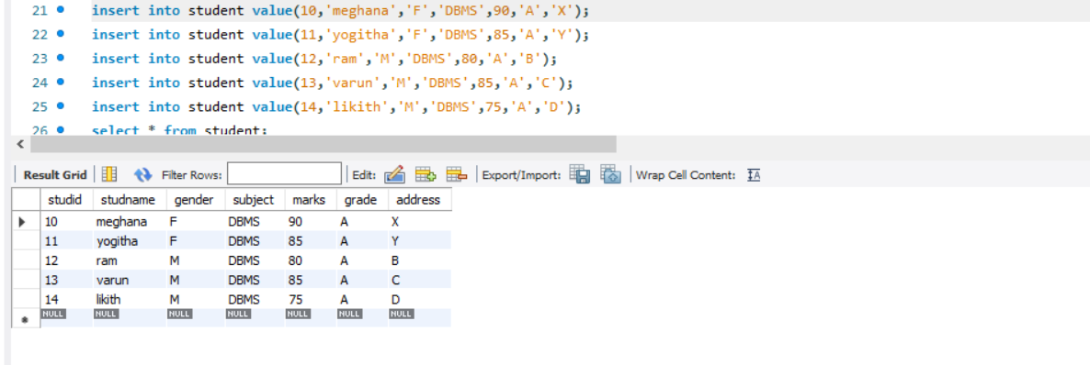

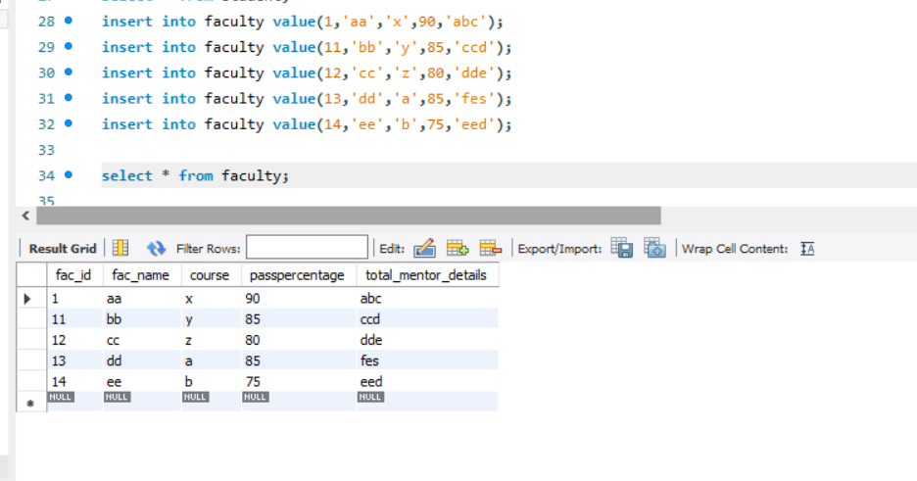

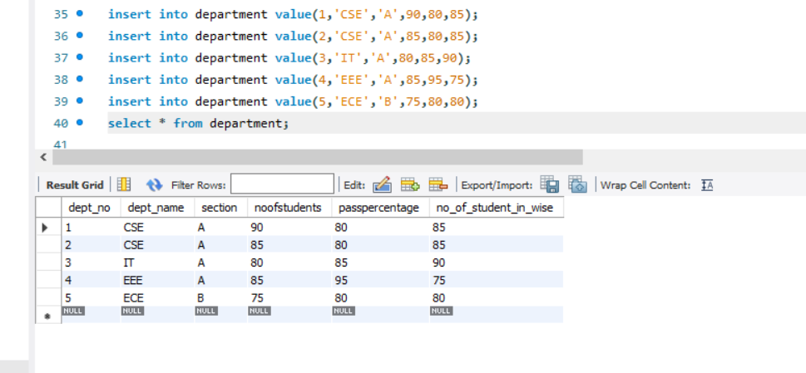

2. Display student no, marks from student table

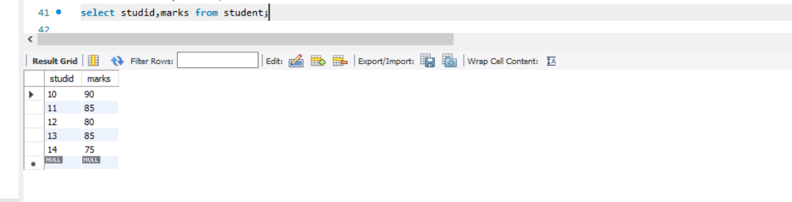

3. Display faculty no, name from faculty table

